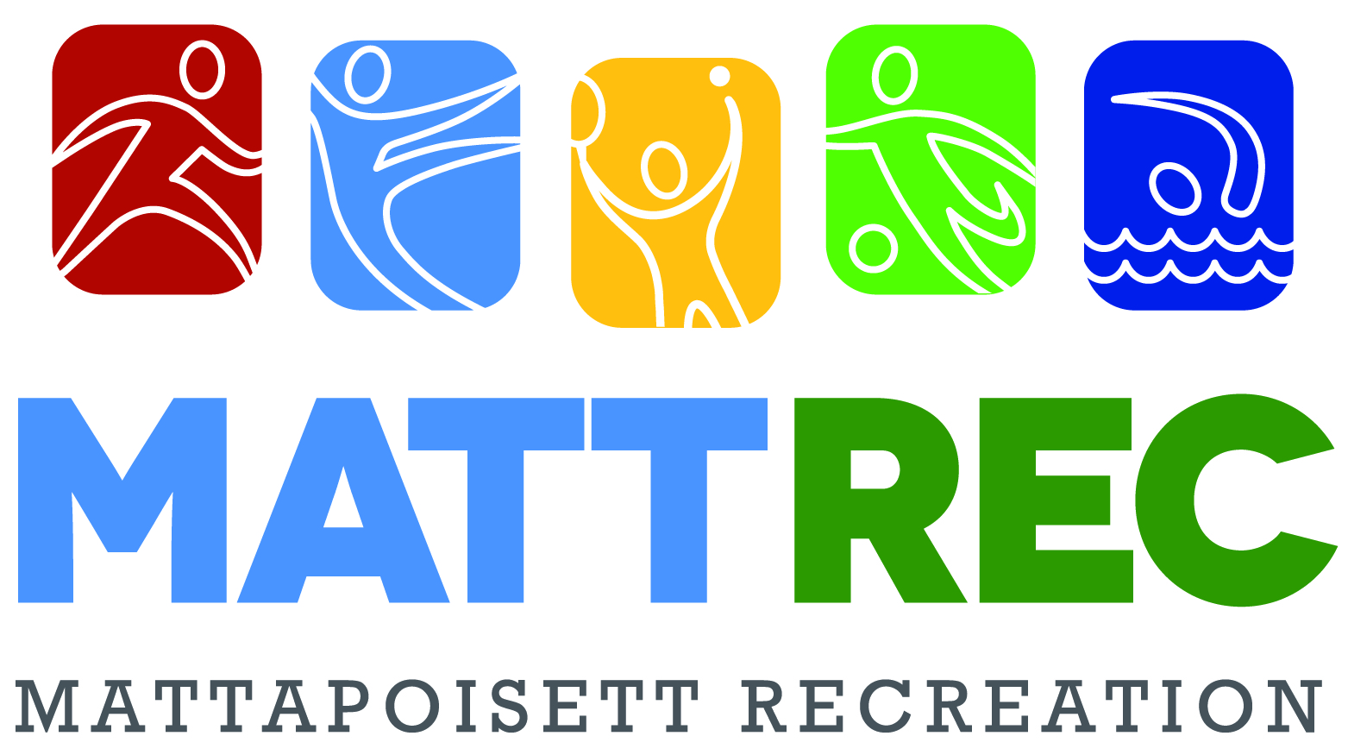
Co-Ed Basketball
Kindergarten & 1st Grade

This Basketball program will be an instructional league. Each session will consist of 45 minutes of basketball related games designed to have your child active and learning the fundamentals of the game while having fun.

SEASON SCHEDULE
After School Sessions: Mondays 3:00- 3:45pm Jan. 13th-March 2nd
Thursdays 3:00-3:45pm Jan. 16th- February 27th
Evening Session: Wednesdays 5:00- 5:45pm Jan. 15th-February 26th
Note: no sessions on school holidays and vacations!
in Center School gymnasium

COST
$55/participant – 6 sessions & t-shirt

REGISTRATION DEADLINE
December 30th
***After school sessions fill quickly so register early!
Register online at www.mattrec.net
Like our Mattapoisett Recreation Facebook Page

$10 off each additional sibling signed up to participate in this program.
Late registrations will only be accepted if space is available.
In the event of school or after school activities cancellation- MATTREC programs will also be cancelled.

For after school participants please note the following:
A note must be provided to the school to dismiss child to MATTREC program in order to participate.
Parent pick-up is at Center School Gym at the end of each class.

Questions or concerns, please email mattrec@mattapoisett.net

Co-Ed Basketball – Kindergarten & 1st Grade Registration Form

Jersey Size (circle one): Youth S M LG XL
Name: _______________________________________________________________________ M/F Grade: _____ Age: _______ DOB:______
Parent(s)/guardian(s) Name: ____________________________________________Best Contact #: _______________________________________
E-mail: __________________________________________________________________________________________________________________
Emergency Contact: Name________________________________________________ Home/Work/Cell# (circle one) ________________________
List any medical condition(s) or allergies we should be aware of? ___________________________________________________________________
I am willing to volunteer to: ______ Coach ___ ___ Assistant Coach Name: _______________________________________________________ Email_____________________________________________________________________________________ Cell #_________________________
*NOTE: all volunteers need to be CORI checked before program begins.

I am registering for the Co-Ed Basketball Kindergarten & 1st Grade Program:
After school session: Mondays______ Thursdays ____ Evening session Wednesdays 5-5:45pm_____
Registration Deadline is December 30th *Please note after school sessions fill up quickly!
Register on-line at www.mattrec.net or make checks payable to Town of Mattapoisett Mail to: MATTREC P.O. Box 435 Mattapoisett, MA 02739

*******MATTREC PROGRAM RELEASE*******
I agree, by signing below, that I give permission to either Center School or Old Hammondtown, to dismiss my child to the appropriate MATTREC program in which they are enrolled. I, further, authorize my child to take the school bus to Center School or Old Hammondtown as necessary so they may attend said program.

Parent/Guardian Signature: _________________________________________________ Date: __________________

The Mattapoisett Recreation Committee approved a ZERO TOLERANCE POLICY to address adverse situations that may occur at any town related sporting event or activity. Our policy includes unruly and/or verbally abusive parents, spectators, coaches or players. Anyone, whose action disrupts, shows poor sportsmanship or in any way adversely affects the participants or programs offered by the committee will be subject to the following: At the discretion of the Recreation Director, Committee member or Game Official, the offender(s) will be asked to leave the building or immediate playing area. Depending on the severity of the incident, further action may be required.
Player Signature: ____________________________________________ Parent/Guardian Signature: ___________________________________ Date: _________

RELEASE OF CLAIMS, IDEMNITY AND HOLD HARMLESS AGREEMENT

I, the undersigned________________________________,(insert your name or name of parent/legal guardian if minor participant) as parent/legal guardian of __________________________________________(insert name if minor is participating in the program) do consent to __________________________________’s__ (participants name) participation in voluntary athletic or recreation program(s) of the Town of Mattapoisett.

I also agree to forever release the Town of Mattapoisett, and all of its employees, officials, agents, board members, volunteers and any and all individuals and organizations assisting with the athletic or recreation activity programs ( The ‘Releasees”) from any and all claims, rights of action, causes of action, damages, costs, compensation and attorney’s fees, that may have arisen in the past, or may arise in the future, directly or indirectly, from personal injuries to _______________________________’s (name of participant) resulting from my participation in athletic or recreation activity program(s).

I also promise, to indemnify, defend, and hold harmless the Releasees against any and all legal claims and proceedings of any description that may have been asserted in the past, or may be asserted in the future, directly or indirectly, arising from personal INJURIES OR DAMAGE TO ANY Town owned property resulting from participation in athletic or recreation activity programs. I also promise to fully reimburse the Town for any property loss or damage as a result of participation in such programs.

I further affirm that I have read this Consent and Release Form and that I understand the contents of this Form. I understand that participation in Town athletic or recreation activity programs is entirely voluntary and that I am free to choose not to participate in said program or have my minor participate in said program. By signing this Form, I authorize participation in athletic or recreation activity programs with full knowledge that the Releasees will not be liable for any damage or injuries resulting from my participation in this program.
________________________________________ ________________________________________________________ (Parent/Legal Guardian-please circle one)
Signature Parent/Guardian Signature (if minor)
Date:_____________ Please Print Name:_______________________________________________________*THIS FORM MAY NOT BE ALTERED

MATTAPOISETT RECREATION POLICIES
Programs will not occur on school holidays, vacations or holiday weekends unless otherwise stated. If ORR School District closes or has an early release due to inclement weather, than youth programs/activities will be cancelled. Photographs and/or video of program participants may be taken by MATTREC for our marketing and social media purposes only. If you do not wish for the participant to be photographed, please note on registration form. Refunds are issued only when a program is cancelled by the Recreation Department or if the participant enrolled in the program has a medical note from a physician’s office stating they are not able to participate in the program due to a medical condition. A $25- refund processing fee will be deducted from refund. For a complete list of MATTREC Policies visit www.mattrec.net. Questions regarding this or any other MATTREC program please e-mail mattrec@mattapoisett.net or call 508-758-4548.

