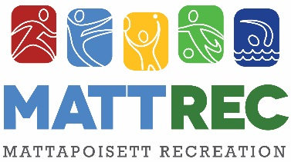

Adult Pickleball Lessons

MATTREC is excited to offer adult pickleball lessons at the
Hammond Street courts. This will be a 6-week clinic
on Thursdays from 4:00-5:00pm
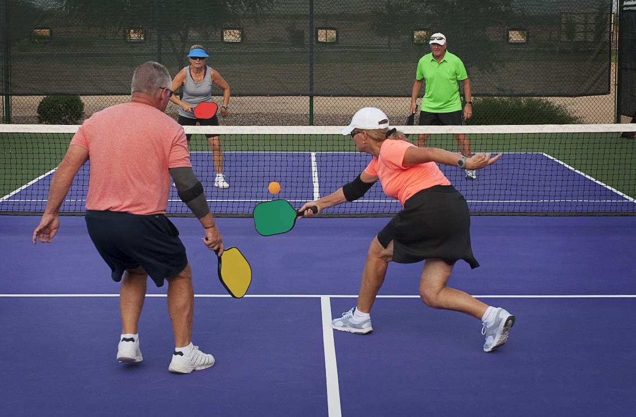

SESSION SCHEDULE
Thursdays April 29th-June 3rd

COST
$80 per participant

REGISTRATION DEADLINE
April 20th

Adult Pickleball drop in is held from 5:00pm- sunset on Thursdays and participants are welcome to stay and play after the clinics!

Spaces are limited so sign up today at www.mattrec.net
Questions? Please email us at mattrec@mattapoisett.net or call us at 508-758-4548.
Participants should arrive with a water bottle and mask.
We will have extra paddles available if you do not have one.

Adult Pickleball Lessons Registration

One Registration per Participant

Name: ___________________________________________________________
Best Contact# ________________________ E-mail:___________________________________________________________
Emergency Contact: _________________________________________Best Contact # _______________________________
List any medical condition(s) or allergies we should be aware of? ________________________________________________
_____________________________________________________________________________________________________

I am registering for Pickleball- Thursdays 4:00-5:00pm ($80):
Registration Deadline is April 20th
Register on-line at www.mattrec.net or make checks payable to Town of Mattapoisett
Mail to: MATTREC P.O. Box 435 Mattapoisett, MA 02739

The Mattapoisett Recreation Committee approved a ZERO TOLERANCE POLICY to address adverse situations that may occur at any town related sporting event or activity. Our policy includes unruly and/or verbally abusive parents, spectators, coaches or players. Anyone, whose action disrupts, shows poor sportsmanship or in any way adversely affects the participants or programs offered by the committee will be subject to the following: At the discretion of the Recreation Director, Committee member or Game Official, the offender(s) will be asked to leave the building or immediate playing area. Depending on the severity of the incident, further action may be required.
Read and Accepted
Player Signature: _________________________________________________________ Date: _________
Parent/Guardian Signature:_________________________________________________ Date: _________

RELEASE OF CLAIMS, IDEMNITY AND HOLD HARMLESS AGREEMENT

I, the undersigned________________________________,(insert your name or name of parent/legal guardian if minor participant) as parent/legal guardian of __________________________________________(insert name if minor is participating in the program) do consent to __________________________________’s__ (participants name) participation in voluntary athletic or recreation program(s) of the Town of Mattapoisett.

I also agree to forever release the Town of Mattapoisett, and all of its employees, officials, agents, board members, volunteers and any and all individuals and organizations assisting with the athletic or recreation activity programs ( The ‘Releasees”) from any and all claims, rights of action, causes of action, damages, costs, compensation and attorney’s fees, that may have arisen in the past, or may arise in the future, directly or indirectly, from personal injuries to _______________________________’s (name of participant) resulting from my participation in athletic or recreation activity program(s).

I also promise, to indemnify, defend, and hold harmless the Releasees against any and all legal claims and proceedings of any description that may have been asserted in the past, or may be asserted in the future, directly or indirectly, arising from personal INJURIES OR DAMAGE TO ANY Town owned property resulting from participation in athletic or recreation activity programs. I also promise to fully reimburse the Town for any property loss or damage as a result of participation in such programs.

I further affirm that I have read this Consent and Release Form and that I understand the contents of this Form. I understand that participation in Town athletic or recreation activity programs is entirely voluntary and that I am free to choose not to participate in said program or have my minor participate in said program. By signing this Form, I authorize participation in athletic or recreation activity programs with full knowledge that the Releasees will not be liable for any damage or injuries resulting from my participation in this program.
________________________________________ ____________________________________________ (Parent/Legal Guardian-please circle one)
Signature Parent/Guardian Signature (if minor)

Date:_____________ Please Print Name:_______________________________________________________*THIS FORM MAY NOT BE ALTERED

MATTAPOISETT RECREATION DEPARTMENT POLICIES
Programs will not occur on school holidays, vacations, scheduled early release days, or holiday weekends unless otherwise stated. If ORR School District closes or has an early release due to inclement weather, than youth programs/activities will be cancelled. Photographs and/or video of program participants may be taken by MATTREC for our marketing and social media purposes only. If you do not wish for the participant to be photographed, please note on registration form. Refunds are issued only when a class is cancelled by the Recreation Department or if the participant enrolled in the program has a medical note from a physician’s office stating they are not able to participate in the program due to a medical condition. A $25- refund processing fee will be deducted from the refund. For a complete list of MATTREC Policies visit www.mattrec.net . Questions regarding this or any other MATTREC program please e-mail mattrec@mattapoisett.net or call 508-758-4548.

