BAY STATE GYMNASTICS ACADEMY
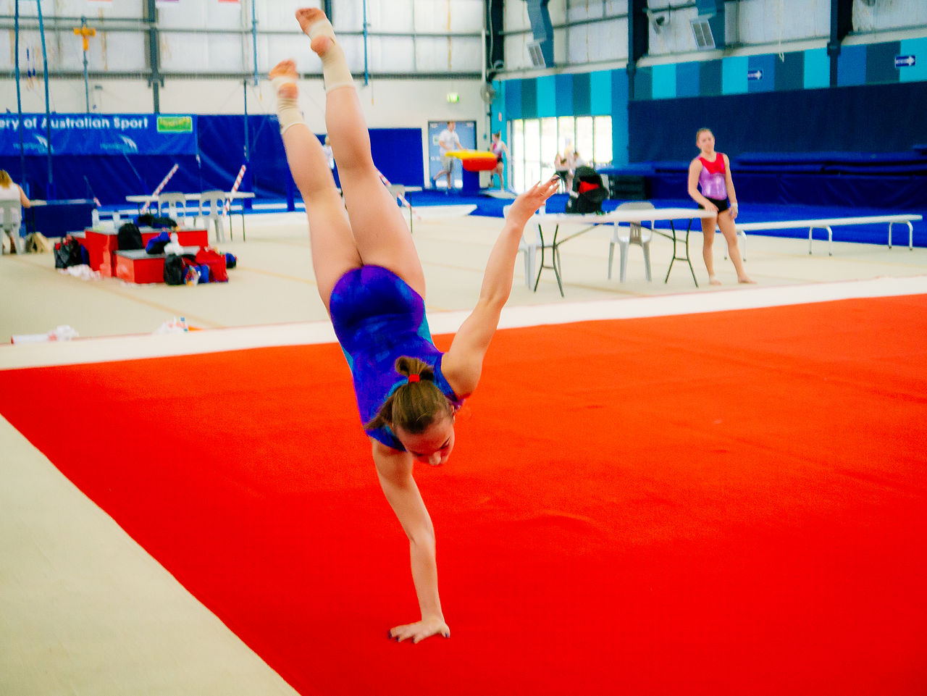GYMNASTICS & TUMBLING SESSION 2

Students will learn gymnastics skills specific to their individual skill level from qualified instructors on all 4 gymnastics events: Floor Tumbling, Balance Beam, Bars and Vaulting. The tumbling classes are designed for any cheerleader or gymnast interested in working solely on their floor tumbling skills. They will learn floor tumbling skills specific to their individual skill level using stations and spotted instruction from our qualified instructors. Girls & Boys age 5+

SESSION SCHEDULE
Gymnastics: 3:15pm & 4:15pm
Tumbling: 4:15pm
Fridays – Jan 10th through March 13th
in the Old Hammondtown School Gym
8 week session (Please note: no class on 1/17 & 2/21 due to school holidays)
Children participating in the 4:15 class will need to arrive at their scheduled class time.

COST
$155.00 a class per participant
Combine Gymnastics and Tumbling classes & get two hours of fun!
$10 off each additional sibling signed up to participate in this program

REGISTRATION DEADLINE: January 1st
Priority registration deadline is: Dec.6th Open registration is: December 7th -January 1st
Bus transportation is available from Center School to Old Hammondtown School at the end of the school day.
A MATTREC permission slip must be provided to the school to dismiss child to MATTREC program in order to participate.
If you would like to send your child with a peanut free snack and drink you may do so.
Parent pick-up is at Old Hammondtown School Gym at the end of each class.

Bay State Gymnastics Session 2- Registration
One Registration Form per Participant

Name: ______________________________________________________________ M / F Grade: ____ Age: _____ DOB:_______
Address: ____________________________________________________ Town: __________________________________________
Parent(s)/guardian(s) Name: ______________________________________________________Best Contact #__________________ E-mail: ______________________________________________________________________________________________________
Emergency Contact: Name_____________________________________ Home/Work/Cell# (circle one) ________________________
List any medical condition(s) or allergies we should be aware of? _______________________________________________________

I am registering for the following program:
3:15 Gymnastics ($155) _________ 4:15 Gymnastics ($155) _________ 4:15 Tumbling($155) __________
Priority registration Deadline: December 6th Registration Deadline: January 1st
Make checks payable to Town of Mattapoisett Mail to: MATTREC P.O. Box 435 Mattapoisett, MA 02739

*******MATTREC PROGRAM RELEASE*******
I agree, by signing below, that I give permission to either Center School or Old Hammondtown, to dismiss my child to the appropriate MATTREC program in which they are enrolled. I, further, authorize my child to take the school bus to Center School or Old Hammondtown as necessary so they may attend said program.

Parent/Guardian Signature: _________________________________________________ Date: _________________________

The Mattapoisett Recreation Committee approved a ZERO TOLERANCE POLICY to address adverse situations that may occur at any town related sporting event or activity. Our policy includes unruly and/or verbally abusive parents, spectators, coaches or players. Anyone whose action disrupts, shows poor sportsmanship or in any way adversely affects the participants or programs offered by the committee will be subject to the following: At the discretion of the Recreation Director, Committee member or Game Official, the offender(s) will be asked to leave the building or immediate playing area. Depending on the severity of the incident, further action may be required. Read and Accepted:
Player Signature: ____________________________________________ Parent/Guardian Signature: _______________________________________Date: _________

RELEASE OF CLAIMS, IDEMNITY AND HOLD HARMLESS AGREEMENT

I, the undersigned________________________________,(insert your name or name of parent/legal guardian if minor participant) as parent/legal guardian of __________________________________________(insert name if minor is participating in the program) do consent to __________________________________’s__ (participants name) participation in voluntary athletic or recreation program(s) of the Town of Mattapoisett.

I also agree to forever release the Town of Mattapoisett, and all of its employees, officials, agents, board members, volunteers and any and all individuals and organizations assisting with the athletic or recreation activity programs ( The ‘Releasees”) from any and all claims, rights of action, causes of action, damages, costs, compensation and attorney’s fees, that may have arisen in the past, or may arise in the future, directly or indirectly, from personal injuries to _______________________________’s (name of participant) resulting from my participation in athletic or recreation activity program(s).

I also promise, to indemnify, defend, and hold harmless the Releasees against any and all legal claims and proceedings of any description that may have been asserted in the past, or may be asserted in the future, directly or indirectly, arising from personal INJURIES OR DAMAGE TO ANY Town owned property resulting from participation in athletic or recreation activity programs. I also promise to fully reimburse the Town for any property loss or damage as a result of participation in such programs.

I further affirm that I have read this Consent and Release Form and that I understand the contents of this Form. I understand that participation in Town athletic or recreation activity programs is entirely voluntary and that I am free to choose not to participate in said program or have my minor participate in said program. By signing this Form, I authorize participation in athletic or recreation activity programs with full knowledge that the Releasees will not be liable for any damage or injuries resulting from my participation in this program.
________________________________________ ________________________________________________________ (Parent/Legal Guardian-please circle one)
Signature Parent/Guardian Signature (if minor)

Date:_____________ Please Print Name:________________________________________________________ *THIS FORM MAY NOT BE ALTERED

MATTAPOISETT RECREATION DEPARTMENT POLICIES
Programs will not occur on school holidays, vacations, scheduled early release days, or holiday weekends unless otherwise stated. If ORR School District closes or has an early release due to inclement weather, than youth programs/activities will be cancelled. Photographs and/or video of program participants may be taken by MATTREC for our marketing and social media purposes only. If you do not wish for the participant to be photographed, please note on registration form. Refunds are issued only when a program is cancelled by the Recreation Department or if the participant enrolled in the program has a medical note from a physician’s office stating they are not able to participate in the program due to a medical condition. A $25- refund processing fee will be deducted from refund. For a complete list of MATTREC Policies visit www.MATTREC.net Questions regarding this or any other MATTREC program please e-mail mattrec@mattapoisett.net or call 508-758-4548.

