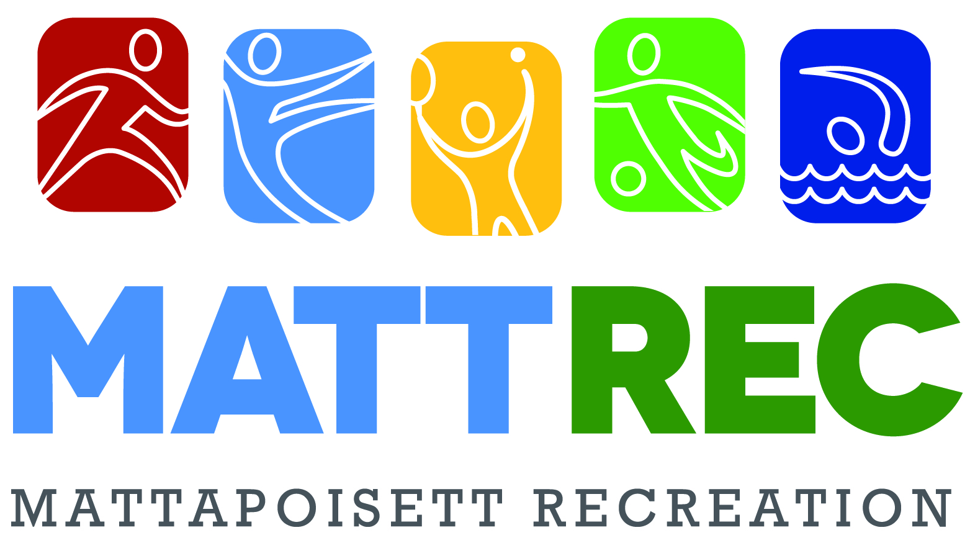
SWIMMING LESSONS

Join us at the Mattapoisett Town Beach for swimming lessons taught

by our certified swimming instructors. Options include Group & Private Lessons.
Group swimming lessons will run for four weeks and will meet on either
Monday and Wednesday or Tuesdays and Thursday mornings.
Class sizes are limited, so sign up early! Classes start July 8th

Group Swimming Lessons
$60/per session-times vary depending on level
Group lessons are tailored to accommodate different swimming levels.
Our lessons are broken down into two groups, Pre-school, catering to 3-5 year olds and Youth which is for ages 6 and up. The Pre-school and the Youth Beginner level classes are 30 minutes long. Youth intermediate level classes are 45 minutes long.
Private Swimming Lessons
1 lesson for $25, 5 lessons for $100
Private Lessons are 30 minutes long. You may choose between 1 or 5 lessons.
Lessons will be held based on availability.
Email mattrec@mattapoisett.net to schedule private swimming lessons.

REGISTRATION DEADLINE JULY 1st
Space is limited, sign up today!

Check out all our programs at www.mattapoisett.net
Like our Mattapoisett Recreation Facebook Page

Swimming lessons will be cancelled due to thunder & lightning or if beach is closed per Board of Health.
We will attempt to make up cancelled classes during the week the cancellation occurred.
All children should have sunscreen applied a minimum of 15 minutes prior to class.

Swimming Lessons Registration Form

Name: ______________________________________________________________________________________________________
Circle One: M / F DOB: ___________________ Grade (In Sept): __________________ Age: __________________
Address: ____________________________________________________________________________________________________
Parent(s)/guardian(s) Name: ____________________________________________________________________________________
Best Contact #: ___________________________ E-mail: _____________________________________________________________
Emergency Contact: Name: ____________________________________ Home/Work/Cell# (circle one) ________________________
List any medical condition(s) or allergies we should be aware: __________________________________________________________________________________________________________

Group Swimming Lessons: Registration Deadline July 3rd Cost: $60 per session
MONDAY AND WEDNESDAY OPTIONS - July 8th – July 31st
Youth Intermediate 9:30am to 10:15am ______________________
Youth Beginner 10:30am to 11:00am______________________
Preschool Beginner/Intermediate 11:00am to 11:30am _____________________

TUESDAY AND THURSDAY OPTIONS – July 9th^{th} – August 1st
Youth Intermediate 9:30am to 10:15am _____________________
Youth Beginner 10:30am to 11:00am ____________________
Preschool Beginner/Intermediate 11:00am to 11:30am ____________________

Private Swimming Lessons: 1 Lesson ($25) ______ 5 Lessons ($100.) ______
You must contact MATTREC to schedule all private swim lessons.
Please check our FACEBOOK page for up to date information on cancellations, etc.
Please make checks payable to the Town of Mattapoisett
Mail to: MATTREC P.O. Box 435 Mattapoisett, MA 02739
The Mattapoisett Recreation Committee approved a ZERO TOLERANCE POLICY to address adverse situations that may occur at any town related sporting event or activity. Our policy includes unruly and/or verbally abusive parents, spectators, coaches or players. Anyone, whose action disrupts, shows poor sportsmanship or in any way adversely affects the participants or programs offered by the committee will be subject to the following: At the discretion of the Recreation Director, Committee member or Game Official, the offender(s) will be asked to leave the building or immediate playing area. Depending on the severity of the incident, further action may be required.
Read and Accepted
Player Signature: _________________________________________________________ Date: _________
Parent/Guardian Signature:_________________________________________________ Date: _________
RECREATIONAL AND VOLUNTEERS ACTIVITIES RELEASE

I, the undersigned________________________________, do hereby consent to my participation (or consent to the child’s participation) in voluntary or recreation program(s) of the Town of Mattapoisett. I also agree to forever release the Town of Mattapoisett, and all their employees, agents, board members, volunteers and any and all individuals and organizations assisting or participating in any voluntary or recreation program(s) of the Town of Mattapoisett from any and all claims, rights of action and causes of action that may have arisen in the past, or may arise in the future, directly or indirectly, from personal injuries to myself or property damage resulting from my participation in the Town of Mattapoisett voluntary activities or recreation program(s). I also promise, to indemnify, defend, and hold harmless the Town of Mattapoisett against any and all legal claims and proceedings of any description that may have been asserted in the past, or may be asserted in the future, directly or indirectly, arising from personal injuries to myself or property damage resulting from participation in the Town of Mattapoisett voluntary activities or recreation program(s). I further affirm that I have read this Consent and Release Form and that I understand the contents of this Form. I understand that my participation is voluntary and that I am free to choose not to participate in said program(s). By signing this Form, I affirm that I have decided to participate in the Town of Mattapoisett as a volunteer or in its recreation program(s) with full knowledge that the Town of Mattapoisett will not be liable to anyone for personal injuries and property damage that I may suffer in volunteer activities for the Town of Mattapoisett or its recreation program(s).
_____________________________________________________________________ _____________________________________________________________________
Signature (Parent/Guardian Signature required if under 18 years of age) Date Signed
MATTAPOISETT RECREATION DEPARTMENT POLICIES
Photographs and/or video of program participants may be taken by MATTREC for our marketing and social media purposes only. If you do not wish for the participant to be photographed, please note on registration form. Refunds are issued only when a class is cancelled by the Recreation Department or if the participant enrolled in the program has a medical note from a physician’s office stating they are not able to participate in the program due to a medical condition. For a complete list of MATTREC Policies visit www.mattrec.net Questions regarding this or any other MATTREC program please e-mail mattrec@mattapoisett.net or call 508-758-4548.

